Professor: Terri Hoare
Prepared by: Homanshu Dalal (10394591)
Muhammad Khubaib Sarfraz (10394873)



CRISP- DM:
Customer Churn Model

Contents
Abstract 4
CRISP-DM 4
Business Understanding 4
Data Understanding & Data Preparation 4
Modeling 5
Evaluation 6
Deployment 7
Appendix A 7
Appendix B 7
Appendix C 7
Class balancing Python Code. 7
Taking mean of missing Values in ‘Balance’ Variable. 8
Appendix D 8
Importing libraries. 8
Encoding Categorical varaible 8
Splitting Data into Test and Train 8
Appendix E 8
Feature Scaling 8
Classifying and Fitting the model 9
Confusion Matrix with 83% Accuracy 9
Appendix F 10
Monte Carlo 10
Optimal number of Tree 10
Optimal Depth of Trees 10

Abstract
According to many losses faced by the bank, this report focuses on developing a model which identifies the customer behavior, which helps to take decisions before invest money into the customer. In our report we have done modelling on the Random Forest algorithm which has around 93% accuracy.
Nowadays, fraud customer is being occurred all over the world. According to the recent news by Times of India, Vijay Malya, Rotomac, Wipro are the top companies have more than 45k trillions loan failed to repay. Not even the big companies but also normal people fail to repay the loan amount. Its very big issue in banking sector which after converts it to the big loss and its result to the cost cutting. As the bank does not have enough money to run their business so they start firing the people from their jobs.
Apart from that, it’s very important to understand the what is customer churn? what is it does? It means rather than acquiring the new customer maintain/ retain the existing customer. The cost for acquiring the new customer is 3 times more than retain the existing the customer. and its very difficult task to identify the profitable customers for organizations. This issue is being solved by the data mining techniques, artificial algorithms, using analysis of OLAP with the help of data warehouse. With the help of these technologies we should able to churn, taking out the useful information which helps to prevent loss to the organizations. Not even information but also, we can define the strategies, plan design to prevent it. Data mining techniques help organizations helps derive loyalty of the valuable customer with them they can do the business. In case of baking sector, bank can provide the loan facilities with low interest price, fewer verification process, providing over draft facilities with low penalty charges, providing credit card with higher limit to them. Ultimately this kind of strategies help to retain the customer. According the Dawkins research around the 5% significant growth has seen in retaining the customer.
This report is mainly focusing on the customer retention and emphasizes on churn management. By the lack of use of technical methodology used by the companies, they can’t catch the fraud customers. So, this report tells you the customer’s loyalty with 93% of accuracy. Not only the predictions but useful insights of datasets with different important variables and their co-relations with each other.

CRISP-DM

CRISP-DM is stands for cross industry standard process for data mining. it was developed in late 1996 to standardize the organization process. Before CRISP – DM process most of the companies used to approach business understanding process in different manner on trial and error basis. And it was very difficult to understand for new user. Hence CRISP-DM came in picture to unify the data mining process. After knowing the importance of CRISP-DM almost every companies started to adopt rapidly. And it published in 2000.
CRISP-DM is the process of data mining project which consist of 6 different stages are as follows and we are implementing these stages in our report.
- Data gathering
- Business requirements/ Understanding the problem
- Data preparation
- Modelling
- Evaluation
- Deployment

Business Understanding
In bank churn dataset, trying to find out the loyalty of customers. Through which organization get to know that while retention to the customers its very important to know which customers should be targeted to offer feasible deal. But how can it get to know? This can be possible with the help of data mining techniques.
In dataset there are 12 columns which are as below
- customer ID – Unique Identification of Customer
- Credit Score – value of customer credit score
- Geography – Location of customer
- Gender – Sex of person
- Age – How old is customer
- Balance – Account balance
- Number of Products – How many of products of bank he is using
- Credit card – Customer has credit card or not
- Active Member – Is active or Not
- Estimated salary – Customer Salary
- Exited – Classification Variable (1 – Loyal, 2- Churn)
In Modelling our output variable is Exited and important columns for finding out the behavior are Credit Score, Age, Balance, Credit card, Active Member and estimated salary.

Data Understanding & Data Preparation

To fully understand and get the insights of data, python is used to plot all the variables as shown below:
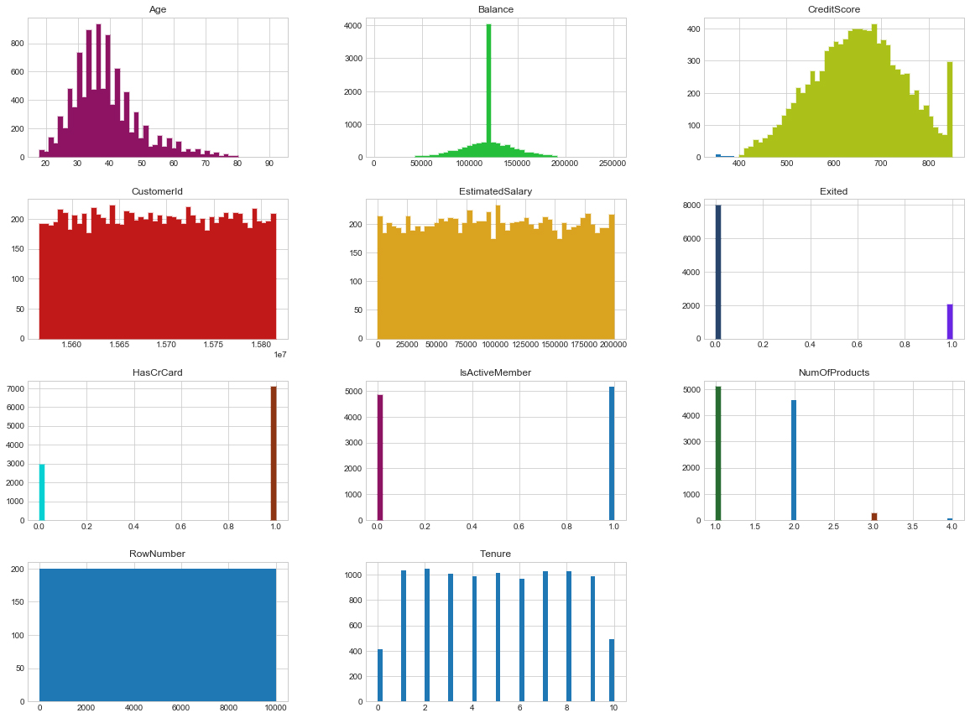
As shown in the exploratory analysis, there are two irrelevant variables in the data, namely Row Number and Customer Id, which are of no use to us for the relevant analysis. Furthermore, the most important insight is to look at the dependent variable which ‘Exited’ variable, that shows weather the customer churn or does not churn and we can clearly see the imbalance class. Hence, if we proceed our analysis without balancing class the results will be misleading. Therefore, both classes are balanced using sklearn in Python (Attached in Appendix A).
Taking a closer look at Age variable, it can be concluded that most of the customers are aged between 30-40 years old. Moreover, for the Balance variable, we had several missing values which are corrected by taking the mean values of the Balance variables in python (Attached in Appendix A)

Modeling

Now when all the data is prepared, it is than used to create a Random Forest Model in Python. For that we purpose several libraries are needed to be called in python (List attached in Appendix B).
- After calling the relevant libraries, CSV file of Bank churn model is imported in python using “pd.read_csv”, as mentioned earlier now this data has been corrected for missing values in ‘Balance’ variable.
- Next step before feeding data to algorithm is to encode the categorical variable; in this case we have ‘Country’ variable with three countries. Hence, three categories are created i.e 1,2 and 3. (Shown in Appendix B)
- Subsequent step is to import sklearn.model_selection library to divide data for testing and training, initially data is divided into 70:30 ratios to perform the analysis which created four new variables namely; X_train, X_test, y_train, y_test.(Shown in Appendix B)
- Furthermore, feature scaling is applied to the data set which helps to normalize the data within a particular range. Sometimes, it also helps in speeding up the calculations in an algorithm.
Process of feature scaling is shown in Appendix C
- Final step is to classify and fit the model by importing RandomForestClassifier from sklearn.ensemble library. Initially, 100 trees are used to check the performance of the algorithm. For this purpose, confusion matric is created by using y_predict and y_test variables and 83% of accuracy is achieved. (Shown in Appendix C). We can observe from the confusion matric that there are 757 wrong and 3521 correct predictions when algorithm is run on the remaining unseen data.

Evaluation

Now when the basic model is prepared, it’s time to fine tune the parameters of Random Forest Algorithm to check if the accuracy can be increased further. For this very purpose Monte Carlo method is applied to the data to find out the optimal ratios for splitting the data so that maximum accuracy can be achieved. Therefore, seven different splitting ratio are fed into Monte Carlo model and plot it on the graph to find out the optimal splitting ratios (Shown in Appendix D). Hence, as show in the graph below 20% test and 80% train splitting ratio provides the maximum accuracy for the model. Therefore, we will replace splitting ratio in our model from 30: 70 to 20:80.
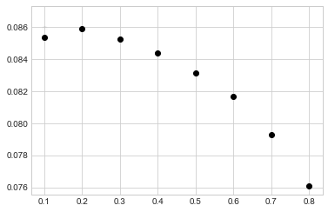
Next step is optimizing the number of trees in the model to check weather performance increase or not. For this purpose, we use ROC curve and AUC in python and visualize them to find the best performing values (As shown in Appendix D). Therefore, we can observer in the following picture that using 20 trees in the model will give the highest accuracy and increasing trees further will just increase the computational time not the accuracy, which will remain constant.
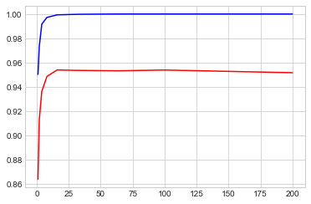

Final step in optimizing the parameters is to find out the ideal trees depth in the model. Initially in the model default values are used, but now using python code (Shown in Appendix D) optimal values are predicted and visualize below:
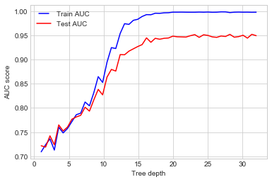
We can conclude that by using Tree Depth size of 15 we can achieve higher accuracy of the model.
Finally, once above mentioned parameters are optimized, it’s time to update our model according to these parameters (Shown in Appendix E)

Deployment
Now, after optimizing the parameters, data is split again according to the new parameters and model is fitted again and is been tested on the new Test data. Therefore, we found out that accuracy of the model has increased massively and by building the confusion matrix below we can clearly see that model accuracy has now move up to 93%.

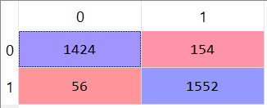

Appendix A

Class balancing Python Code.
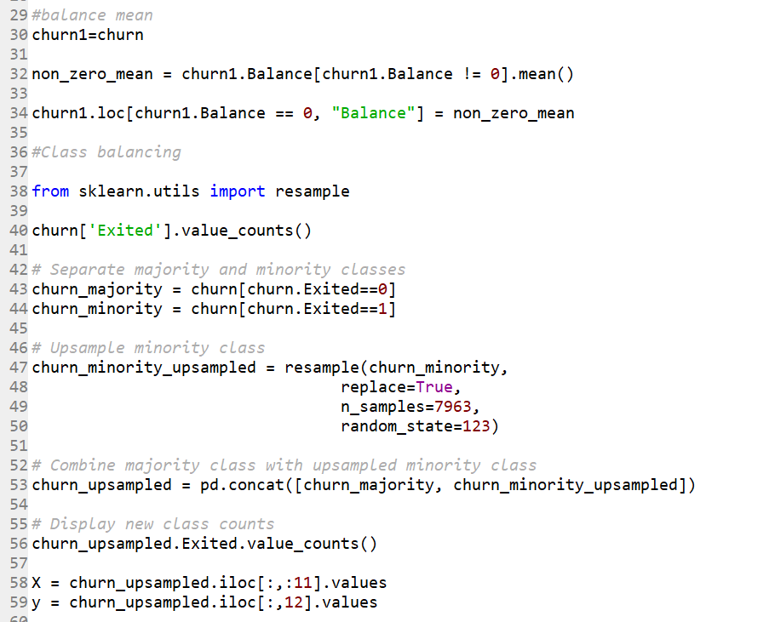

Taking mean of missing Values in ‘Balance’ Variable.
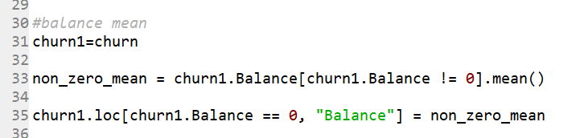

Appendix B

Importing libraries.
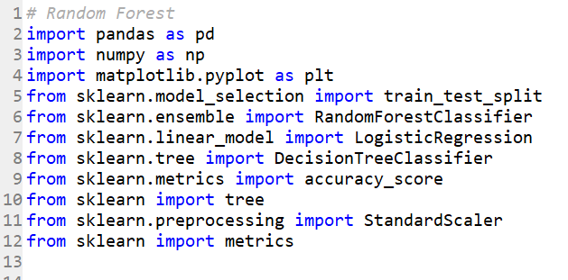

Encoding Categorical varaible
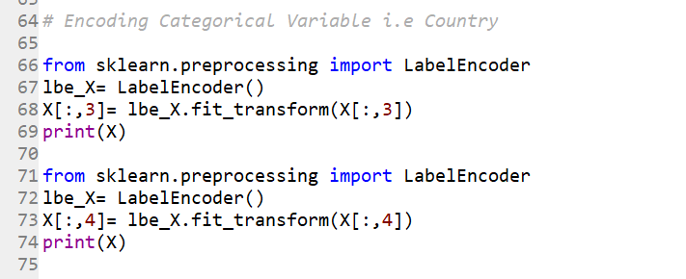

Splitting Data into Test and Train
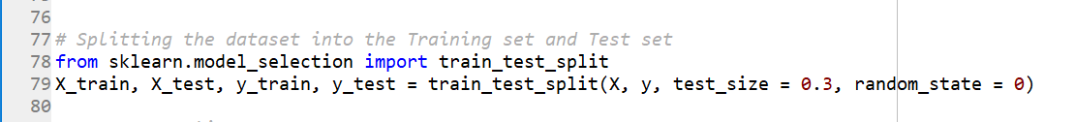

Appendix C

Feature Scaling

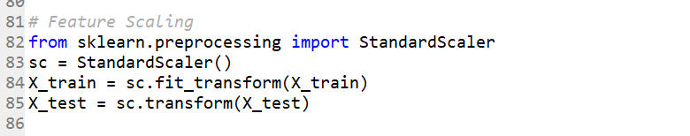

Classifying and Fitting the model
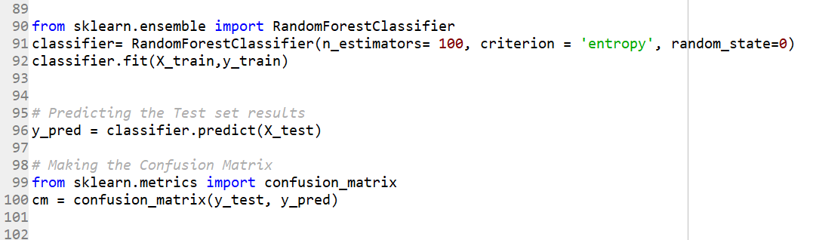

Confusion Matrix with 83% Accuracy
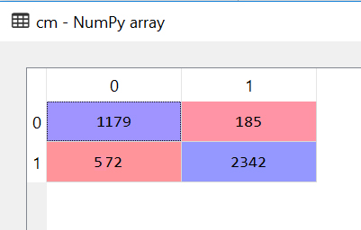

Appendix D

Monte Carlo

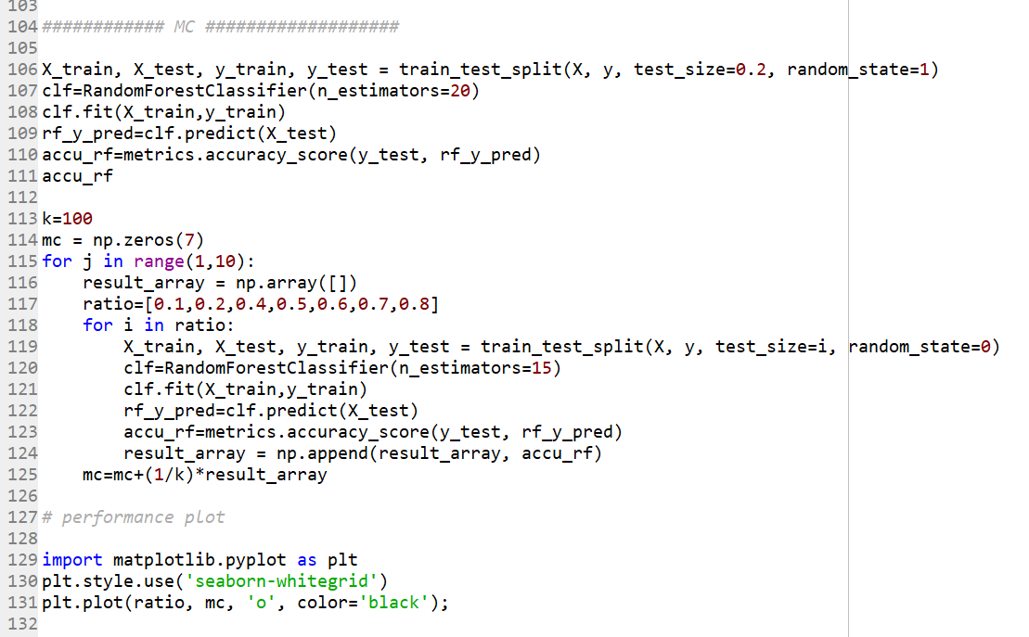

Optimal number of Tree
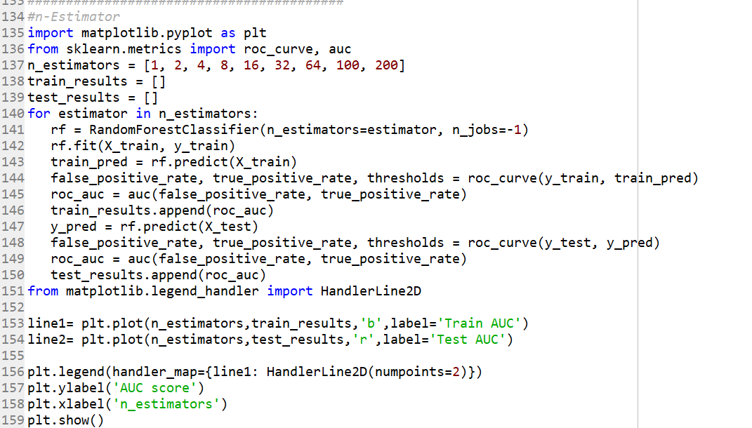

Optimal Depth of Trees

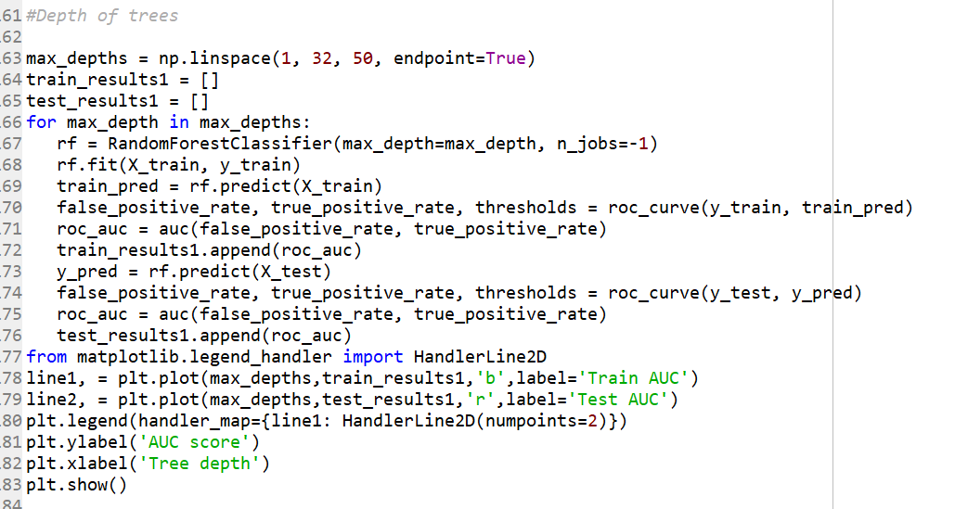

Appendix E

Updating Model with Optimized Parameters

